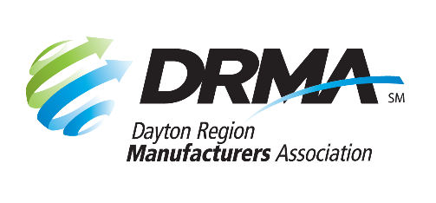
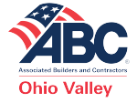
33 Greenwood Lane
Springboro, OH 45066
P: (513) 470-3882 F: (937) 704-9394
Tammy@ovabc.org www.ovabc.org

205 E. First St., Ste. 202
Dayton, OH 45402
P: (937) 949-4000 F: (937) 949-4007
NKubik@DaytonRMA.org www.DaytonRMA.org

SPONSORSHIP OPPORTUNITIES

Contractors & Manufacturers Regional Conference

September 16, 2021 / Sinclair Conference Center

Promote your business at DRMA’s and ABC’s Contractors & Manufacturers Regional Conference. This half-day conference features an economist from nationally renowned ITR Economics and Jim Spurlino, local multi-millionaire and author of Business Bullseye: Take Dead Aim and Achieve Great Success. In addition, breakout sessions covering topics important to contractors and manufacturers will be offered. Get your brand in front of 200+ attendees from member companies and guests.

 | Presenting  $10,000  (1 available) | Platinum  $5,000  (unlimited) | Gold  $2,500  (unlimited) | Silver  $1,500  (unlimited) | Bronze  $500  (unlimited)
Recognition during program | Make remarks | Company name & promotional sentence in script | Group thank you | Group thank you | Group thank you
Event program | Logo & large ad | Logo & medium ad | Name & small ad | Name | Name listed in breakout section
Registration list | Yes
Guaranteed breakout session speaking opportunity |  | Yes
Sponsor name badges | Yes
Display table | Yes | Yes
Website event page | Logo - 1st position | Logo - 2nd position | Name - 3rd position | Name - 4th position
Featured in promotional emails about the event | Logo - 1st position | Logo - 2nd position | Name - 3rd position | Name - 4th position
Press release about the event | Mentioned
Complimentary tickets | 8  (reserved table with signage) | 4  (reserved seating with signage) | 2 | 1
Breakout session sponsorships |  |  |  |  | Yes
Signage at event | Logo – 1st position | Logo – 2nd position | Name – 3rd position | Name – 4th position
Sponsorship selected:

Company: |  |  | Phone:
Contact Name: |  |  | Email:
Date Submitted:

Check (make payable to DRMA Foundation) |  |  |  |  |  |  |  |  |  |  | Credit card (all major cards accepted)
Card #:
Exp. Date: |  |  |  |  |  | CVV Code: |  |  |  |  |  |  |  | Billing Zip Code:

DRMA members and partners: Return form with payment to the DRMA office.
ABC members and partners: Return form with payment to the ABC office.

