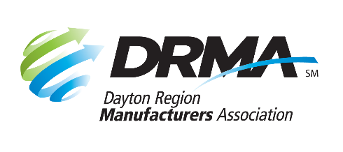
22 E. Fifth St., Ste. 100-B
Dayton, OH 45402
(937) 949-4000 (937) 949-4007 fax
SKnoll@DaytonRMA.org www.DaytonRMA.org

DRMA GD&T Workshop
Registration Form

DRMA’s GD&T Workshop, exclusively for DRMA members, will teach skills that increase participants’ ability to read and interpret blueprints and engineering drawings and better understand the ASME Y14.5 GD&T standard. This two-part workshop, presented by the Workforce Division of Sinclair College, covers concepts of datums, tolerances, symbols, features and material conditions as applied to the production and inspection of machined parts and assemblies. A certificate of completion will be provided at the end of the second session.

Please complete and return this form with payment to register.

Session Dates: Session #1 – Friday, June 4; Session #2 - Friday, June 11

Time: 8:00 – 11:00 a.m.

Location: Sinclair Conference Center (301 W. Fourth St., Dayton 45402)

Cost: $175 per person for both sessions; includes parking, breakfast, and a copy of the GD&T Hierarchy Pocket Guide. (This is a reduced rate because Sinclair is providing tuition assistance; participants will need to complete a short form the morning of the first session. A copy of the form will be attached to the confirmation email.) Notice of cancellation must be received by end of day on Thursday, May 27, in order to receive a refund.

Registrant Information
Company:
Name | Title | Email

Payment Information
Number of Participants: |  | X $175 = | TOTAL = $

Check (make payable to DRMA) |  |  |  |  |  |  |  |  |  |  | Credit card (all major cards accepted)
Card #:
Exp. Date: |  |  |  |  |  | CVV Code: |  |  |  |  |  |  |  | Billing Zip Code:

Return this form with payment to DRMA via mail, email, or fax.

